Telenor Microfinance Bank and Telenor Group Executives meet with Jack Ma in Hangzhou, China
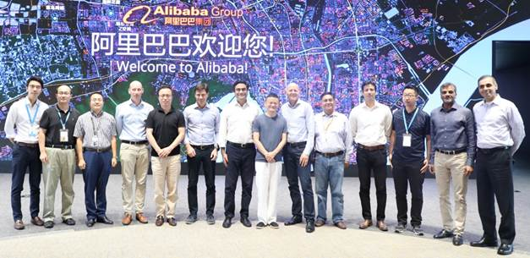
KARACHI – July 3, 2018: The senior management of Telenor, comprising Telenor Group CEO Sigve Brekke, Telenor Microfinance Bank President & CEO Shahid Mustafa, and Telenor Pakistan CEO Irfan Wahab Khan, met with Alibaba CEO Jack Ma and Ant Financial CEO Eric Jing, besides other senior officials from Alibaba Group and Ant Financial in China’s city Hangzhou, last week.
The meeting underscored the significance of a cashless society, especially in the context of a developing country like Pakistan. The officials exchanged thoughts and ideas about digitization of the world’s financial landscape and looked into more ways the big strategic partnership between Telenor Group and Ant Financial earlier this year could prove more fruitful.
Telenor officials also exchanged thoughts on how digitization will enhance accessibility to formal financial services in Pakistan. “We pioneered branchless banking in Pakistan with Easypaisa to bridge the widening financial services divide in the country,” said Shahid Mustafa, CEO Telenor Microfinance Bank. “Today, we’re even more committed to transforming the Pakistani financial landscape using innovative technology and breakthrough partnerships like the one with Ant Financial,” he added.
In March this year, Telenor Group entered into an agreement with Ant Financial, formerly known as Alipay, where Ant Financial announced an investment of US $184.5m for a 45% stake in Telenor Microfinance Bank (TMB), a subsidiary of Telenor Group, to further develop mobile payment and digital financial services in Pakistan. Ant Financial is dedicated to bringing the world more equal opportunities through building a technology-driven open ecosystem and working with other financial institutions to support the future financial needs of society.

# # #

